Perchtoldsdorf, 22.08.2019

Display & Interfaces
In addition to parameters such as size, resolution, or brightness, when choosing a display developers must also consider the issue of control. The display interface constitutes an important component, since it is responsible for transferring the data (images) to be displayed from the computer to the screen as efficiently as possible. On the one hand, the choice will depend on the interfaces offered by the panel manufacturers and, on the other, one must also take into account the parameters of the controlling CPU.
The following will focus on what I refer to as the "internal interfaces". These involve the direct connection of a display to a processor or controller, and in most cases both the latter are situated in the same package. In contrast, the "external interfaces" require a signal conversion, in some cases from digital to analogue and vice versa. These interfaces (VGA, Composite Video, S-Video, DVI, HDMI or DisplayPort) can be found in monitors or LCD projectors, which are connected to a computer. Their advantage are standardized ports (connector, pin assignment), which allow for an easy connection using commercial cables.
Let's return to the display interfaces, however, and examine their pros and cons in detail:
I²C (Inter-Integrated Circuit, or I2C)
I²C was invented by Philips in 1982, but it was brought to the market by competitors, with Motorola, NEC, TI, Intersil and Siemens leading the way.
This interface was developed as a multi-master, multi-slave, single-ended serial bus system to allow for the simple communication of peripheral components such as EEPROMs, AD/DA converters, and even keyboards with a microcontroller. The system requires only 2 lines (SCL – serial clock and SDA – serial data), uses an asynchronous protocol, and works on short distances on a printed circuit board or within a device. This interface is used in small displays with low resolution, since the data speed required for the transmission of image information does not need to be so high. Naturally, these are small TFTs with up to 320x240 pixels, graphic LCDs, or PMOLED displays. I²C, however, is also one of the most widespread interfaces used for the connection of projected capacitive touch sensors.
Advantages:
- low energy consumption
- insensitive to interference
- simple application and troubleshooting
- bandwidth up to 1Mbit/sec
SPI (Serial Peripheral Interface)
SPI, a bus system developed by Motorola in 1987, is a synchronous serial interface for data interchange between two devices such as, e.g. memory, sensors, AD converters, or real-time clocks. The system works bi-directionally in full duplex mode, i.e. data are transferred on a carrier simultaneously in both directions. A master communicates with several slaves independently of each other. This means that data can be transferred to the display but not vice versa. A small disadvantage of this interface is the number of pins required - each slave needs its own chip-select pin on the master.
SPI is also used in small displays with low resolution. In order to fit higher resolution displays with SPI, one must provide for additional intelligence (memory, controller) on the panel side, since the interface speed does not suffice for direct image transmission. The data must be buffered in the display before they can be displayed.
Advantages:
- Simple implementation
- Longer lines possible
- Faster than I²C
- Bandwidth up to approx. 10Mbit/sec
MCU (Microcontroller Unit)
In order to keep the connection of a display as simple as possible while increasing the speed of data transmission, manufacturers have always resorted to parallel interfaces. Already developed back in the 1970s, this interface was already part of the first microcontrollers. A 8(9)-bit or 16(18)-bit wide data bus connects all peripheral units in a microprocessor system with the CPU. The display can be easily integrated in this bus. Based on the two original µC technologies, the interfaces can be operated both in 8080 and 6800 compatible modes. Due to the parallel data processing and the resulting higher bandwidth, it is possible to control medium-size displays and a medium colour depth.
Advantages:
- Easy integration in the system
- Also suitable for medium-size displays
- Bandwidth up to approx. 120Mbit/sec
RGB (red, green, blue)
The RGB interface is an exceptional case of a parallel interface. No video memory is required on the display side, and the processor is completely responsible for the control. Data words 6 or 8 bits wide are sent for each colour (red, green, and blue). This allows for significantly larger amounts of data to be made available in a short time. Its disadvantage, however, is the large number of lines, which requires more expensive connectors and results in a worse EMC behaviour. RGB is widely used in small and medium-size displays.
Advantages:
- Relatively low costs as a result of its mature technology
- High performance
- Bandwidth up to 1.2Gbit/s
LVDS (Low-Voltage Differential Signalling)
LVDS was developed in 1994 and is currently the most widely used interface standard for displays. It delivers the required high bandwidth for high-resolution graphics and videos at high refresh rates. The 18-bit or 24-bit colour information is converted into a serial data stream, transferred at a high speed (7 times the frequency of the original), and then reconverted to the original information. The interface works with differential signals, i.e. the information is read by the receiver as a difference between the voltages on the pair of lines. This reduces noise levels, improves EMC behaviour, and keeps power consumption low. Therefore, the transmission is also immune from external interference.
The LVDS interface is used in medium-sized and large displays. Where the resolution requires a higher bandwidth (this is the case at approx. 1.5 million pixels or more), the interface can be easily expanded to two (dual LVDS) or four ports (quad LVDS).
Advantages:
- Low power consumption
- Very good EMC behaviour
- Small number of lines
- Bandwidth up to 3.125Gbit/s
eDP (embedded Display Port)
eDP is a standard which was defined by VESA (Video Electronics Standards Association) in 2008. It uses hardware similar to the LVDS, yet with fewer line pairs and a higher speed. The basic idea behind it was to circumvent the limitations posed by LVDS in large, high-resolution displays. Inter was one of the first to embed the interface into its Bay Trail Atom processors, and is planning to support only eDP in the future. In practice, the interface is usually encountered in large monitor panels, though it is not widely used in industrial applications.
Advantages:
- Scalable
- Easy integration
- Low system costs
- Bandwidth of 1.62Gbits/s per lane
MIPI DSI (Mobile Industry Processor Interface – Display Serial Interface)
The MIPI Alliance is behind a whole series of standards for mobile devices. In view of the widespread use of mobile phones, it also designed an interface for such displays. Similar to LVDS, DSI is built as a differential interface with 4 or 8 line pairs, so-called lanes, and a clock line pair. A disadvantage of this interface is the complex protocol and driver software. The latter supports high-speed and energy-saving modes and also offers the possibility to read data back from the display at a low speed.
Currently, only a small number of displays using MIPI DSI are available for industrial applications. The displays offered are mostly those originating from mobile telephone or tablet applications, i.e. medium-size (5", 10.1") displays with high resolution. It is becoming evident, however, that this range will gradually increase in the future. Manufacturers like Qualcomm have embedded the interface in their chipsets and believe that there is also a market for this interface among industrial customers. Moreover, the MIPI consortium is encouraging its adoption in other areas as well, for instance in automotive or digital signage applications.
Advantages:
- Low energy consumption,
- High data throughput
- Little electromagnetic interference
- Small number of pins
- Bandwidth up to 6/12Gbit/s
Vx1 (V-by-One)
In 2007, Thine Electronics, too, developed an interface intended to replace LVDS in large displays. The advantage of Vx1 is that despite having a similar structure to LVDS, it is also possible to use affordable twisted-pair copper cables (merely the impedance of 100Ω must be met), and the achievable transmission speed is nevertheless higher. Despite the advantage of low-cost hardware, this interface has (so far) failed to make a breakthrough.
Advantages:
- It is possible to use standard cables
- No software adjustment
- Bandwidth up to 4 Gbit/s
Therefore, when choosing a suitable display, optics is not the end of the story; selecting the right interface requires an equal amount of attention. We will support you in your considerations.

Bild:

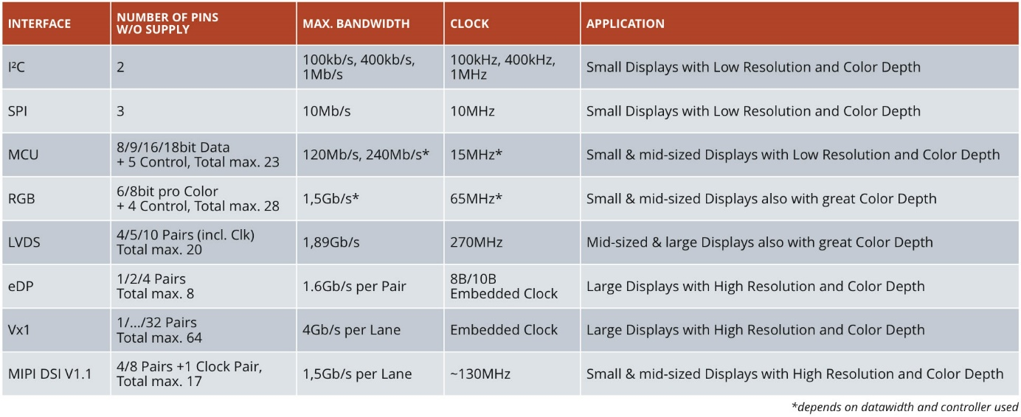

Characters (incl. spaces):
8.873 (incl. spaces)

For further questions:
Christian Forthuber
CODICO Product Manager
christian.forthuber@codico.com
+43 (1) 86305 - 158

About CODICO
CODICO stands for design-in-distribution of high-quality electronic components. Its wide range of products includes active and passive components and interconnect systems. The company operates from its Austrian headquarters in Perchtoldsdorf, south of Vienna as an independent, privately-owned enterprise and maintains several sales offices in Germany, Denmark, Italy, France, the Czech Republic, Slovenia, and the UK, also cooperating with partner companies in Central and Eastern Europe. Backed by a high level of technical expertise, CODICO places a key focus on design-in services. CODICO's distinguishing feature consists in the technical support it provides from the development phase to the final product, and its commitment to selling exclusively high-quality products.
www.codico.com

